03. Traversal

- Print the Preorder traversal of a tree iteratively.

void preorder(Node* root)
{
if (root == NULL)
{
return;
}

stack<Node*> s;
s.push(root);

while (!s.empty())
{
Node *n = s.top();
s.pop();
printf("%d ", n->data);

if (n->right != NULL)
{
s.push(n->right);
}

if (n->left != NULL)
{
s.push(n->left);
}
}
}

- Print the Inorder traversal of a tree iteratively.

void inOrder(Node *root)
{
stack<Node*> s;
Node *curr = root;

while (curr != NULL || !s.empty())
{
while (curr != NULL)
{
s.push(curr);
curr = curr->left;
}

curr = s.top();
s.pop();

cout << curr->data << " ";
curr = curr->right;
}
}

- Print the Postorder traversal of a tree iteratively.

void postorder(Node* root)
{
if (root == NULL)
{
return;
}

stack<Node*> s1;
s1.push(root);

stack<int> s2;
while (!s1.empty())
{
Node *n = s1.top();
s1.pop();
s2.push(n->data);

if (n->left != NULL)
{
s1.push(n->left);
}

if (n->right != NULL)
{
s1.push(n->right);
}
}

while (!s2.empty())
{
printf("%d ", s2.top());
s2.pop();
}
}

- Construct a tree from the given Inorder and Preorder traversals.

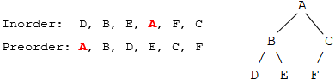

Node *buildTree(char in[], char pre[], int n)
{
if (n == 0)
{
return NULL;
}

int i = 0;
while (in[i] != pre[0])
{
++i;
}

Node *node = new Node(pre[0]);

node->left = buildTree(in, pre + 1, i);
node->right = buildTree(in + i + 1, pre + i + 1, n - i - 1);

return node;
}

- Given Inorder and Preorder traversals of a binary tree, print Postorder traversal.
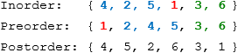

void postorder(int in[], int pre[], int n)
{
if (n == 0)
{
return;
}

int i = 0;
while (in[i] != pre[0])
{
++i;
}

printPostOrder(in, pre + 1, i);
printPostOrder(in + i + 1, pre + i + 1, n - i - 1);

printf("%d ", pre[0]);
}

- Given the Inorder and Level-Order traversals of a binary tree, construct the binary tree.

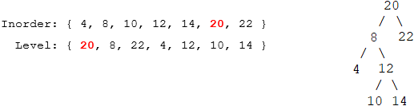

Node* buildTreeUtil(int in[], int start, int end, unordered_map<int, int> &um)
{
if (start > end)
{
return NULL;
}

if (start == end)
{
return new Node(in[start]);
}

// find the node with smallest level:
int minIndex = um[in[start]];
for (int i = start + 1; i <= end; ++i)
{
if (minIndex > um[in[i]])
{
minIndex = um[in[i]];
}
}

Node *node = new Node(in[minIndex]);

node->left = buildTreeUtil(in, start, minIndex - 1, m);
node->right = buildTreeUtil(in, minIndex + 1, end, m);

return node;
}

Node* buildTree(int in[], int level[], int n)
{
unordered_map<int, int> um;
for (int i = 0; i < n; ++i)
{
um[level[i]] = i;
}

return buildTreeUtil(in, 0, n-1, um);
}

- Given the Preorder and Postorder traversals of a full binary tree, construct the binary tree. A Full Binary Tree is a binary tree where every node has either 0 or 2 children.
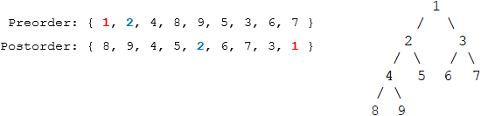

Node *constructTree(int pre[], int post[], int n)
{
if (n < 1)
{
return NULL;
}

Node *node = new Node(pre[0]);
if (n == 1)
{
return node;
}

// find pre[1] in postorder array:
int i = 0;
while (i < n && post[i] != pre[1])
{
++i;
}

node->left = constructTree(pre + 1, post, i + 1);
node->right = constructTree(pre + i + 2, post + i + 1, n - i - 2);

return node;
}

- Given an array that represents the preorder traversal of a special binary tree where every node has either 0 or 2 children, and another array which has only two possible values 'L' and 'N', where 'L' indicates that the node is a leaf node and 'N' indicates that the node is an internal node. Construct the tree from the given two arrays.

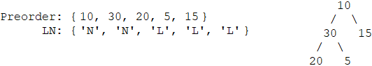

Node *constructUtil(int pre[], char ln[], int n, int &index)
{
if (index >= n)
{
return NULL;
}

Node *node = new Node(pre[index]);
if (ln[index] == 'L')
{
return node;
}

++index;
node->left = constructUtil(pre, ln, n, index);

++index;
node->right = constructUtil(pre, ln, n, index);

return node;
}

Node *construct(int pre[], char ln[], int n)
{
int index = 0;
return constructUtil(pre, ln, n, index);
}

- Given the preorder of a binary tree, calculate its depth. The preorder is given as a string with two possible characters: 'l' denotes a leaf and 'n' denotes an internal node. For example, "nlnll" can represent the following binary tree. The depth and height of a tree are same.

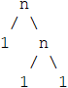

int findDepthUtil(char tree[], int n, int &index)
{
if (index >= n || tree[index] == 'l')
{
return 0;
}

index++;
int lc = findDepthUtil(tree, n, index);

index++;
int rc = findDepthUtil(tree, n, index);

return max(lc, rc) + 1;
}

int findDepth(char tree[], int n)
{
int index = 0;
findDepthUtil(tree, n, index);
}

- Construct a binary tree from a string consisting of parenthesis and integers, such as "4(2(3)(1))(6(5))".

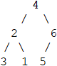

Node *treeFromString(char str[], int n, int &index)
{
if (index == n)
{
return NULL;
}

Node *root = new Node(str[index] - '0');

++index;
if (index < n && str[index] == '(')
{
++index; // skip '('
root->left = treeFromString(str, n, index);
++index; // skip ')'

if (index < n && str[index] == '(')
{
++index; // skip '('
root->right = treeFromString(str, n, index);
++index; // skip ')'
}
}

return root;
}

- Given a string that contains ternary expressions, build a binary tree. String "a?b?c:d:e" builds the following tree.
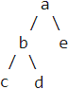

Node *convertExpression(char str[], int n, int &index)
{
if (index == n)
{
return NULL;
}

Node *root = new Node(str[index]);
++index;

if (index < n && str[index] == '?')
{
++index; //skip '?'
root->left = convertExpression(str, index);

++index; // skip ':'
root->right = convertExpression(str, index);
}

return root;
}

- Given an ancestor matrix mat[n][n] which is defined as below.
- mat[i][j] = 1, if i is ancestor of j
- mat[i][j] = 0, otherwise
Construct a binary tree from a given ancestor matrix where all the nodes values are from 0 to n-1.

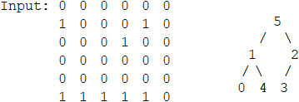

Node* buildTree(int mat[N][N])
{
int degree[N] = {0};

for (int j = 0; j < N; ++j)
{
for (int i = 0; i < N; ++i)
{
if (mat[i][j] == 1)
{
++degree[j];
}
}
}

queue<Node*> q;
Node *root;

for (int j = 0; j < N; ++j)
{
if (degree[j] == 0)
{
root = new Node(j);
q.push(root);
break;
}
}

while (!q.empty())
{
Node *n = q.front();
q.pop();

for (int j = 0; j < N; ++j)
{
if (mat[n->data][j] == 1)
{
--degree[j];

if (degree[j] == 0)
{
if (n->left == NULL)
{
n->left = new Node(j);
q.push(n->left);
}
else
{
n->right = new Node(j);
q.push(n->right);
}
}
}
}
}

return root;
}

- Given an array containing the Preorder traversal of a full k-ary tree, construct the tree. A full k-ary tree is a tree where each node except that leaves has k child nodes. For example, given {1, 2, 5, 6, 7, 3, 8, 9, 10, 4, 11, 12, 13} and k = 3.

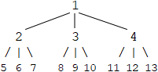

struct Node
{
int data;
vector<Node*> child;
};

Node *BuildTree(int pre[], int n, int k)
{
if (n == 0)
{
return NULL;
}

Node *root = new Node(pre[0]);

++pre;
--n;

if (n == 0)
{
return root;
}

if (n % k != 0)
{
printf("Invalid data.\n");
return NULL;
}

int childSize = n / k;
for (int i = 0; i < k; ++i)
{
Node *node = BuildTree(pre, childSize, k);
root->child.push_back(node);
pre += childSize;
}

return root;
}

- Given an array which contains the Preorder traversal of a complete k-ary tree, construct the tree. For example, given {1, 2, 5, 6, 7, 3, 8, 9, 4} and k = 3, we have:

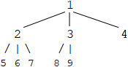

Node *BuildTree(int pre[], int n, int k)
{
if (n == 0)
{
return NULL;
}

Node *root = new Node(pre[0]);

++pre;
--n;

if (n <= k)
{
for (int i = 0; i < n; ++i)
{
root->child.push_back(new Node(pre[i]));
}

return root;
}

int num1 = 0; // the number of nodes for height
int num2 = k; // the number of nodes for (height + 1)
int height = 1;

while (num2 < n)
{
++height;
num1 = num2;
num2 *= k;
}

int extra = n - num1; // the number of extra nodes
int numOfSub = num1 / k; // the number of nodes of every child
int numOfLeaves = pow(k, height - 1); // the number of leaves of a child

for (int i = 0; i < k; ++i)
{
int size = numOfSub;
if (extra > 0)
{
size += min(extra, numOfLeaves);
extra -= numOfLeaves;
}

Node *node = BuildTree(pre, size, k);
root->child.push_back(node);
pre += size;
}

return root;
}

- Given a binary tree and each node has a next pointer, set the next pointer to the Inorder successor node.

void setNext(Node* root)
{
static Node *next = NULL;

if (root == NULL)
{
return;
}

setNext(root->right);

root->next = next;
next = root;

setNext(root->left);
}

The following shows how to use non-static variable.

void setNext(Node* root, Node **next)
{
if (root == NULL)
{
return;
}

setNext(root->right, next);

root->next = *next;
*next = root;

setNext(root->left, next);
}

- Given the array representation of a complete binary tree, output the Inorder traversal of the nodes. For example, given {5, 6, 7, 8, 9, 10, 11}, output 8, 6, 9, 5, 10, 7, 11.

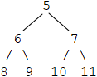

void inorder(int a[], int n, int index)
{
if (index >= n)
{
return;
}

inorder(a, n, index * 2 + 1);
printf("%d ", a[index]);
inorder(a, n, index * 2 + 2);
}

int main()
{
int a[] = { 5, 6, 7, 8, 9, 10, 11 };
int n = sizeof(a) / sizeof(a[0]);

inorder(a, n, 0);
}

- Given a binary tree and an array, check if the array is the Postorder traversal of the binary tree.

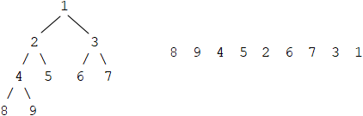

bool checkUtil(Node* root, int post[], int &index)
{
if (root == NULL)
{
return true;
}

if (checkUtil(root->left, post, index) == false)
{
return false;
}

if (checkUtil(root->right, post, index) == false)
{
return false;
}

return post[index++] == root->data;
}

bool check(Node* root, int post[], int n)
{
int size = getSize(root);
if (size != n)
{
return false;
}

int index = 0;
return checkUtil(root, post, index);
}

- The following shows how to delete a tree in post order.

void deleteUtil(Node *node)
{
if (node == NULL)
{
return;
}

deleteUtil(node->left);
deleteUtil(node->right);

free(node);
}

void deleteTree(Node *&root)
{
deleteUtil(root);
root = NULL;
}

